CROSS TABLE
Friday, 24 June 2011 17:04 | Written by Administrator | | |
 | 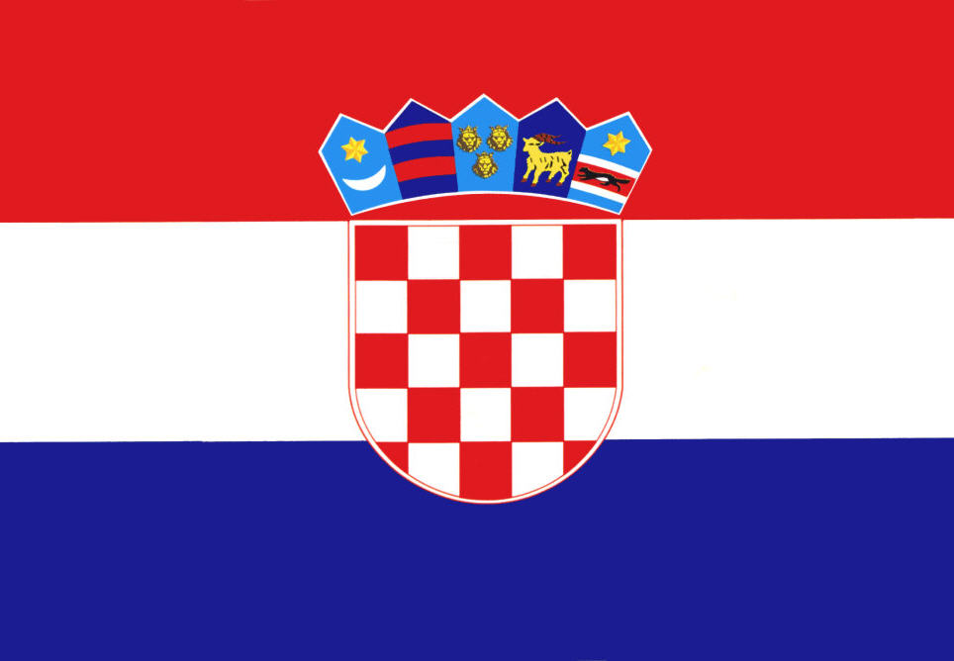 | 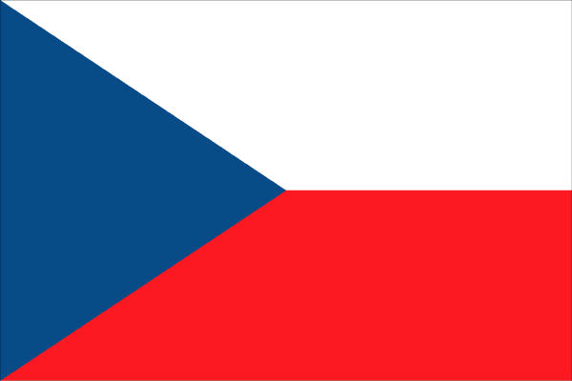 | 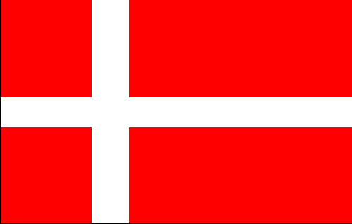 | 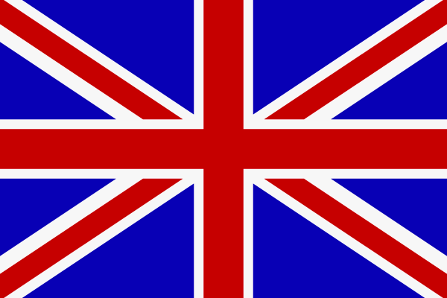 | 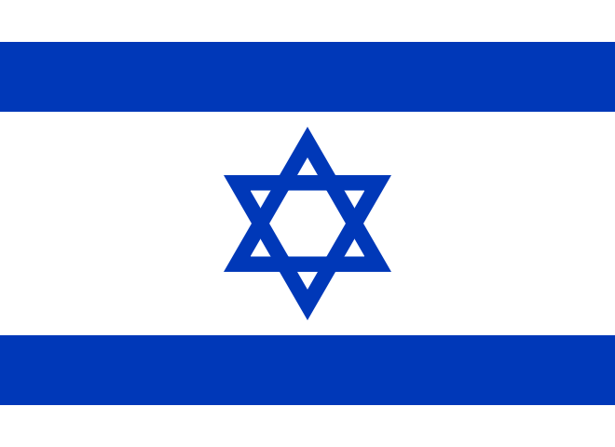 | P | S
 | CROATIA | CZECH  REPUBLIC | DENMARK | GREAT  BRITAIN | ISRAEL | P | S
 |  | 0:16 | 1:7 | 15:5 | 17:2 | 11 | 58:86
CROATIA |  | 3:10 | 4:22 | 7:17 | 11:7 | 11 | 58:86
 | 16:0 |  | 14:0 | 20:0 | 7:0 | 16 | 117:3
CZECH  REPUBLIC | 10:3 |  | 7:0 | 23:0 | 20:0 | 16 | 117:3
 | 7:1 | 0:14 |  | 13:6 | 14:6 | 14 | 71:39
DENMARK | 22:4 | 0:7 |  | 10:0 | 5:1 | 14 | 71:39
 | 5:15 | 0:20 | 6:13 |  | 18:8 | 10 | 52:105
GREAT  BRITAIN | 17:7 | 0:23 | 0:10 |  | 6:9 | 10 | 52:105
 | 2:17 | 0:7 | 6:14 | 8:18 |  | 9 | 33:98
ISRAEL | 7:11 | 0:20 | 1:5 | 9:6 |  | 9 | 33:98

Last Updated (Friday, 15 July 2011 14:32)

